

Project: Sports Fields Management System
Software Design Specification

- Hanoi, 2026 -

Record of changeS
Date | A*  M, D | In charge | Change Description
*A - Added M - Modified D - Deleted

Table of Contents
I. Overview 4
1. Code Packages 4
2. Database Design 5
2.1 Database Schema 5
2.2 Table Description 6
II. Code Designs 7
1. Login 7
1.1 Class Diagram 7
1.2 Class Specifications 9
1.3 Sequence Diagram(s) 15
2. Register 17
2.1. Class Diagram 17
2.2 Class Specifications 17
2.3 Sequence Diagram(s) 20
3. Feedback 21
3.1 Class Diagram 21
3.2 Class Specifications 22
3.3 Sequence Diagram(s) 26
4. Booking field 27
4.1 Class Diagram 27
4.2 Class Specifications 28
4.3 Sequence diagram 31

I. Overview

1. Code Packages
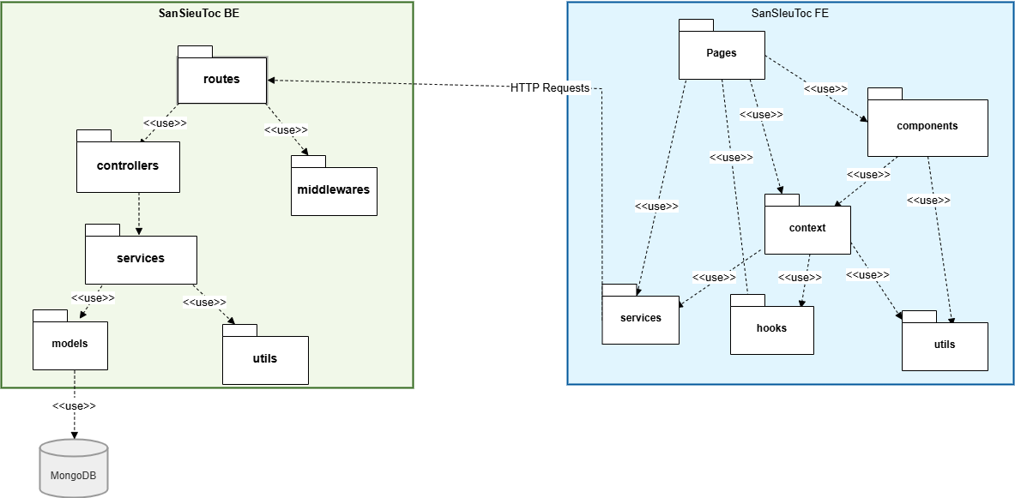
Figure I.1: Code package

Package descriptions
Table I.1: Package description
No | Package | Description
I | Backend (BE) | Server-side processing (Node.js/Express)
01 | routes | Defines all API endpoints and maps incoming HTTP requests to the corresponding controller functions.
02 | controllers | Receives requests from Routes, performs input validation, and orchestrates calls to the Service layer.
03 | middlewares | Handles cross-cutting concerns that run before controllers, such as Authentication (Auth), Logging, and Error handling.
04 | services | The core Business Logic layer of the application (e.g., booking logic, payment processing, or customer management).
05 | models | Contains general-purpose helper functions for the backend, such as password encryption, date formatting, or response helpers.
06 | utils | Contains general-purpose helper functions for the backend, such as password encryption, date formatting, or response helpers.
II | Frontend (FE) | Client-side user interface (React.js)
07 | Pages | High-level components representing different views or routes in the application (e.g., Home Page, Field Details).
08 | components | Small, reusable UI elements (Buttons, Inputs, Cards) used as building blocks for the Pages.
09 | context | Manages the Global State of the application, such as user authentication info, notifications, or global app data.
10 | services | Contains functions for making asynchronous API calls (typically using axios) to fetch data from the Backend.
11 | hooks | Custom React hooks used to encapsulate and reuse complex component logic across different parts of the UI.
12 | utils | General frontend helpers, such as currency formatting (VND), string manipulation, or LocalStorage management.
III | Database | Data Storage
14 | MongoDB | A NoSQL database used to persistently store all application data, including bookings, customers, and field information.

2. Database Design

2.1 Database Schema
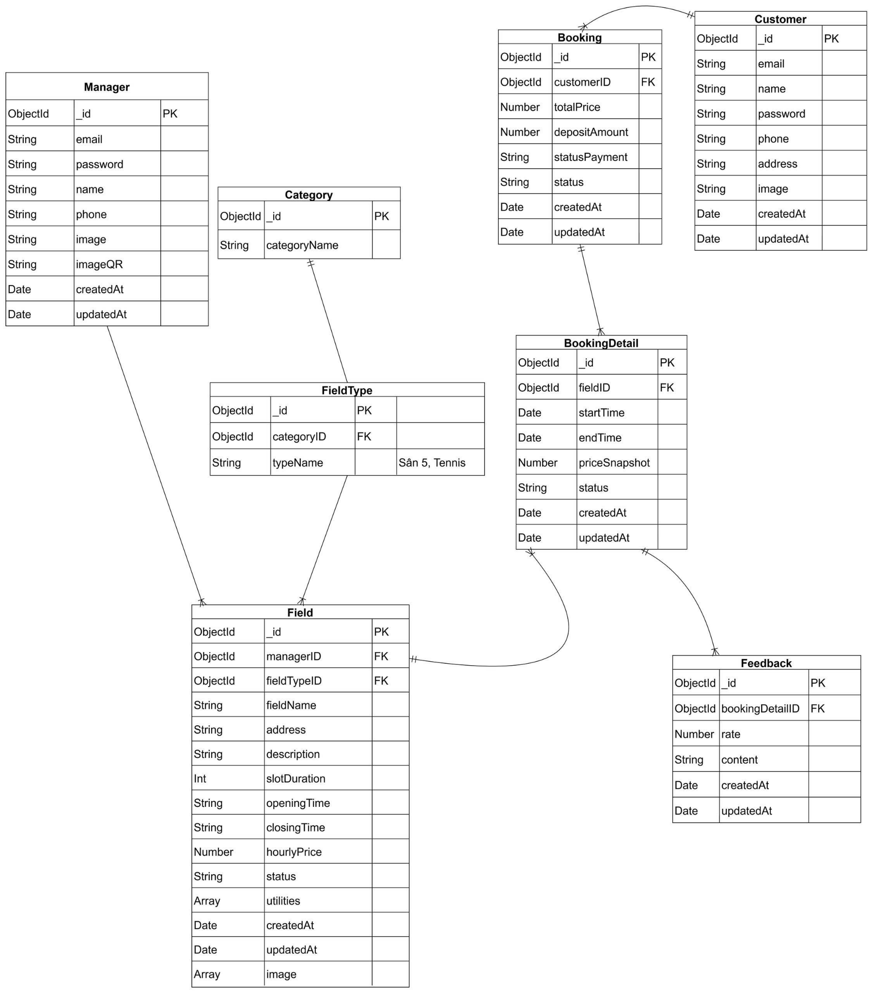
Figure I.2: Database schema

2.2 Table Description
Figure I.2: Database description
No | Table | Description
1 | Manager | Stores information of system administrators and operation staff. Contains login credentials, and imageQR for receiving physical bank transfers from customers.
2 | Category | Stores top-level sport classifications (e.g., Football, Tennis). Acts as the parent entity to categorize specific field types.
3 | FieldType | Defines specific variations of a sport category (e.g., 5-a-side, 7-a-side)
4 | Field | The core entity representing a physical field. It directly stores all configuration data including address, openingTime, closingTime, hourlyPrice, list of utilities (e.g., Wifi, Parking), an array of images (URL strings) and contains the slotDuration rule used by the system to automatically generate time slots.. It links directly to FieldType (Rules).
5 | Customer | Stores personal information, login credentials, and contact details of the end-users (players).
6 | Booking | Acts as the "Transaction Header" or "Shopping Cart". Stores the summary of a booking session, including the totalPrice of all selected slots, depositAmount paid, and the overall payment status (statusPayment).
7 | BookingDetail | (Embedded inside Booking in MongoDB) Stores detailed information for each reserved slot. Contains the reference to the specific Field, the booked time range (startTime, endTime), and the priceSnapshot to record the historical price at the moment of booking.
8 | Feedback | Stores customer reviews and ratings (rate) for a specific completed booking slot. Directly linked to BookingDetail to ensure customers review the exact field and experience they used.

II. Code Designs

1. Login

1.1 Class Diagram

a. Customer
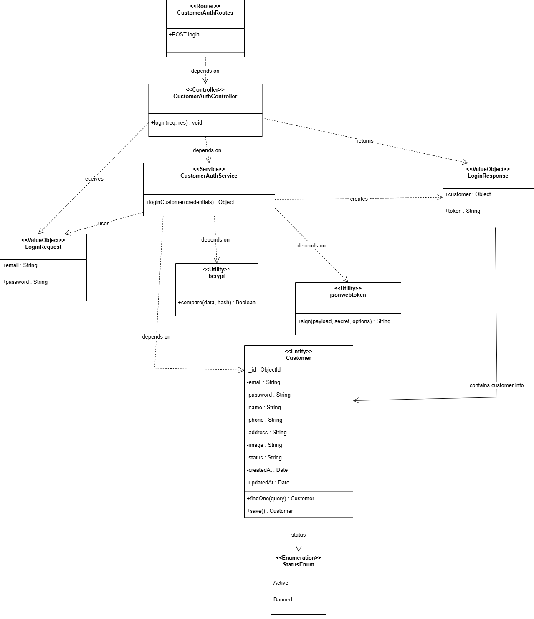
Figure II.1: Class diagram - Customer Login

b. Manager

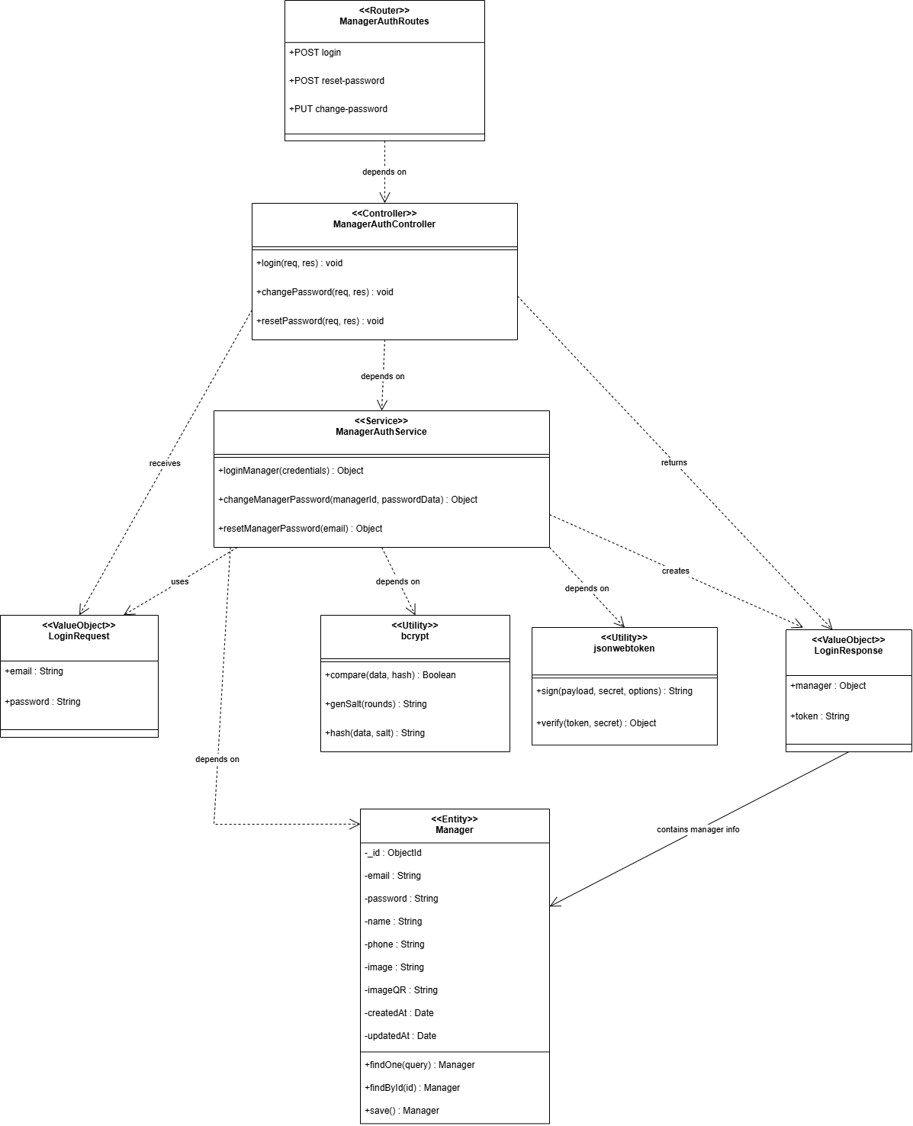
Figure II.2: Class diagram - Manager Login

1.2 Class Specifications

a. Customer
Table II.1: Class specification - Customer Login
- Class LoginController

No | Method | Description
1 | loginCustomer(req, res) | Input: HTTP Request  Output: HTTP Response  Processing:  - Extract data from req.body  - Validate that the request body contains all required fields  - Call LoginService.loginCustomer(data)  - Return 200 OK with customer data (excluding password)  - Catch error

- Class LoginService

No | Method | Description
1 | loginCustomer  (loginData) | Input: Object {email, password}  Output: Promise<Customer> (without password field)  Processing:  - Validate all input data via ValidationService.validateEmail().  - Validate password via ValidationService.validatePassword().  - Throw ValidationException if data is invalid.  - Check if email exists: checkEmailExists(email).  - Compare password via PasswordService.comparePassword(password, hashedPassword).  - If password matches → Remove password field from object → Return customer object (without password).  - If password does not match → Throw UnauthorizedException("Invalid password").  - Catch error
2 | checkEmailExists(email) | Input: String email  Output: Promise<Customer>  Processing:  - Call CustomerModel.findByEmail(email).  - If customer found → Return customer object.  - If not found → Throw NotFoundException("Email not registered").

- Class CustomerModel

No | Method | Description
1 | findByEmail  (email) | Input: String email  Output: Promise<Customer | null>  Processing:  - Query MongoDB using Mongoose to find customers by email.  - Return customer document if found.  - Return null if not found.
2 | findById(id) | Input: ObjectId or String id  Output: Promise<Customer>  Processing:  - Query MongoDB to find customers by _id.  - Return customer document if found.  - Return null if not found.

- Class ValidationService

No | Method | Description
1 | validateEmail(email) | Input: String email  Output: ValidationResult {isValid: boolean, message?: string}  Processing:  - Check if the email is null/undefined/empty.  - Validate email format  - Check email length <= 255 characters.  - Return {isValid: true} if valid.  - Return {isValid: false, message: "Invalid Email"} if failed.
2 | validatePassword  (password) | Input: String password  Output: ValidationResult {isValid: boolean, errors?: string[]}  Processing:  - Check not empty.  - Check min length >= 8 characters.  - Return {isValid: true} if valid.  - Return {isValid: false, errors: ["error messages"]} if failed.

- Class PasswordService

No | Method | Description
1 | comparePassword(password, hash) | Input: String password (plaintext), String hash  Output: Promise<boolean>  Processing:  - Use bcrypt.compare(password, hash).  - Return true if match, false otherwise.

b. Manager
Table II.2: Class specification - Manager Login
- Class LoginController
No | Method | Description
1 | loginManager  (req, res) | Input: HTTP Request  Output: HTTP Response  Processing:  - Extract data from req.body  - Validate that the request body contains all required fields  - Call LoginService.loginManager(data)  - Return 200 OK with customer data (excluding password)  - Catch error

- Class LoginService

No | Method | Description
1 | loginManager  (loginData) | Input: Object {email, password}  Output: Promise<<Manager> (without password field)  Processing:  - Validate all input data via ValidationService.validateEmail().  - Validate password via ValidationService.validatePassword().  - Throw ValidationException if data is invalid.  - Check if email exists: checkEmailExists(email).  - Compare password via PasswordService.comparePassword(password, hashedPassword).  - If password matches → Return customer object (without password).  - If password does not match → Throw UnauthorizedException("Invalid password").  - Catch error
2 | checkEmailExists(email) | Input: String email  Output: Promise<Manager>  Processing:  - Call ManagerModel.findByEmail(email).  - If manager found → Return manager object.  - If not found → Throw NotFoundException("Email not registered").

- Class ManagerModel

No | Method | Description
1 | findByEmail  (email) | Input: String email  Output: Promise<Manager | null >  Processing:  - Query MongoDB using Mongoose to find a manager by email.  - Return manager document if found.  - Return null if not found.
2 | findById(id) | Input: ObjectId or String id  Output: Promise<Manager>  Processing:  - Query MongoDB to find a manager by _id.  - Return manager document if found.  - Return null if not found.

- Class ValidationService
No | Method | Description
1 | validateEmail(email) | Input: String email  Output: ValidationResult {isValid: boolean, message?: string}  Processing:  - Check if the email is null/undefined/empty.  - Validate email format  - Check email length <= 255 characters.  - Return {isValid: true} if valid.  - Return {isValid: false, message: "Invalid Email"} if failed.
2 | validatePassword  (password) | Input: String password  Output: ValidationResult {isValid: boolean, errors?: string[]}  Processing:  - Check not empty.  - Check min length >= 8 characters.  - Return result.

- PasswordService
No | Method | Description
1 | comparePassword(password, hash) | Input: String password (plaintext), String hash  Output: Promise<boolean>  Processing:  - Use bcrypt.compare(password, hash).  - Return true if match, false otherwise.

1.3 Sequence Diagram(s)

Customer
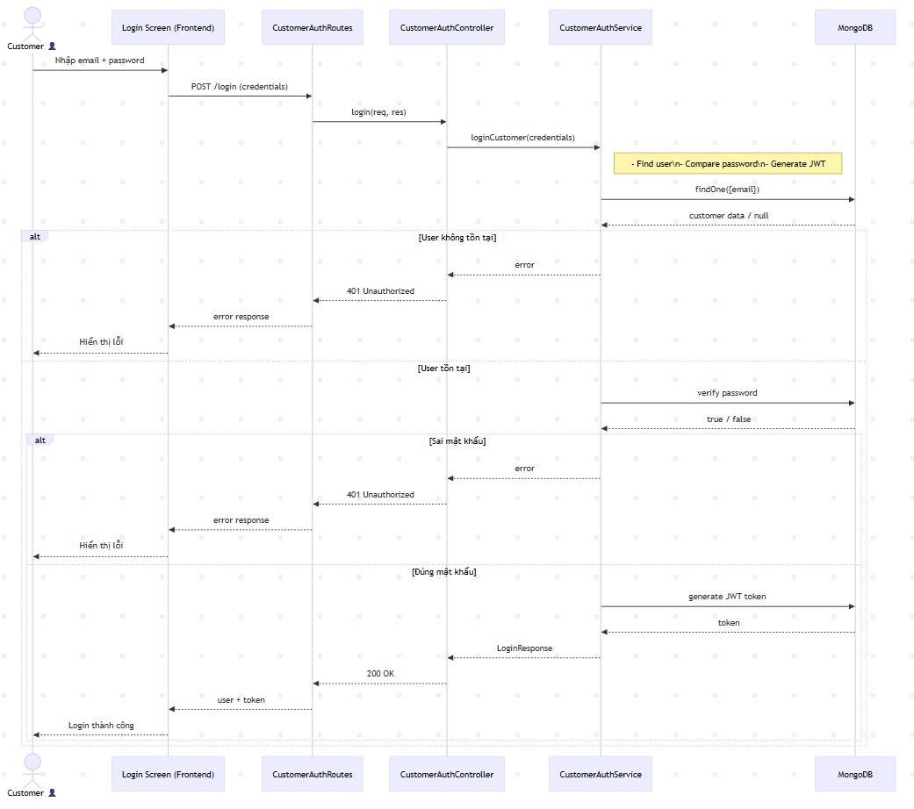
Figure II.3: Sequence diagram - Customer Login

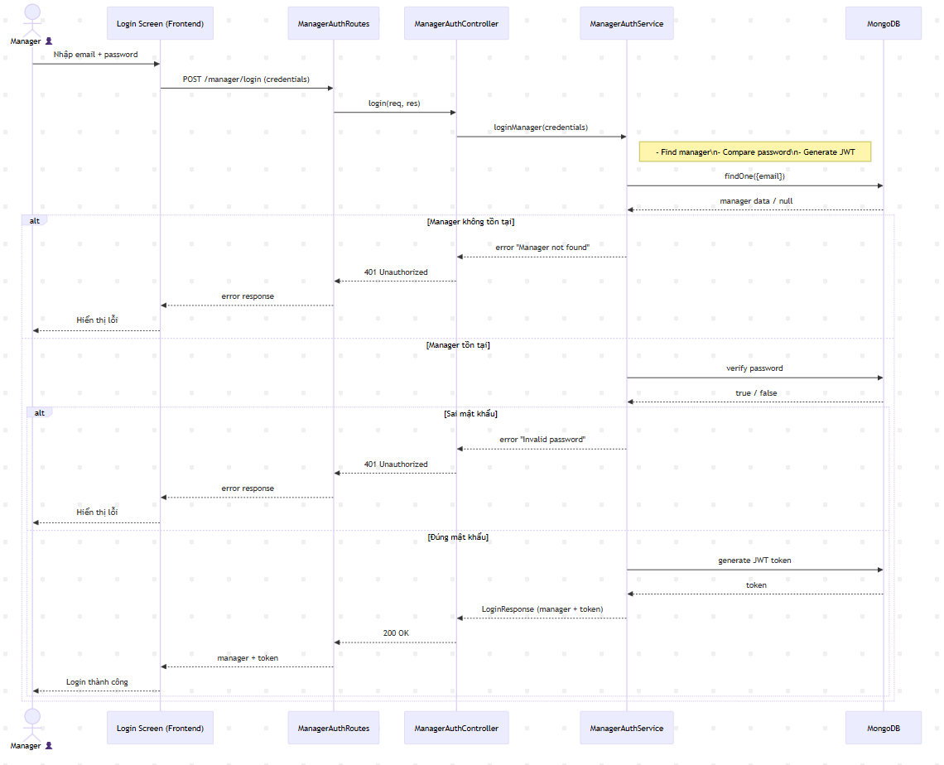
Figure II.4: Sequence diagram - Manager Login

2. Register

2.1. Class Diagram
- Class RegisterController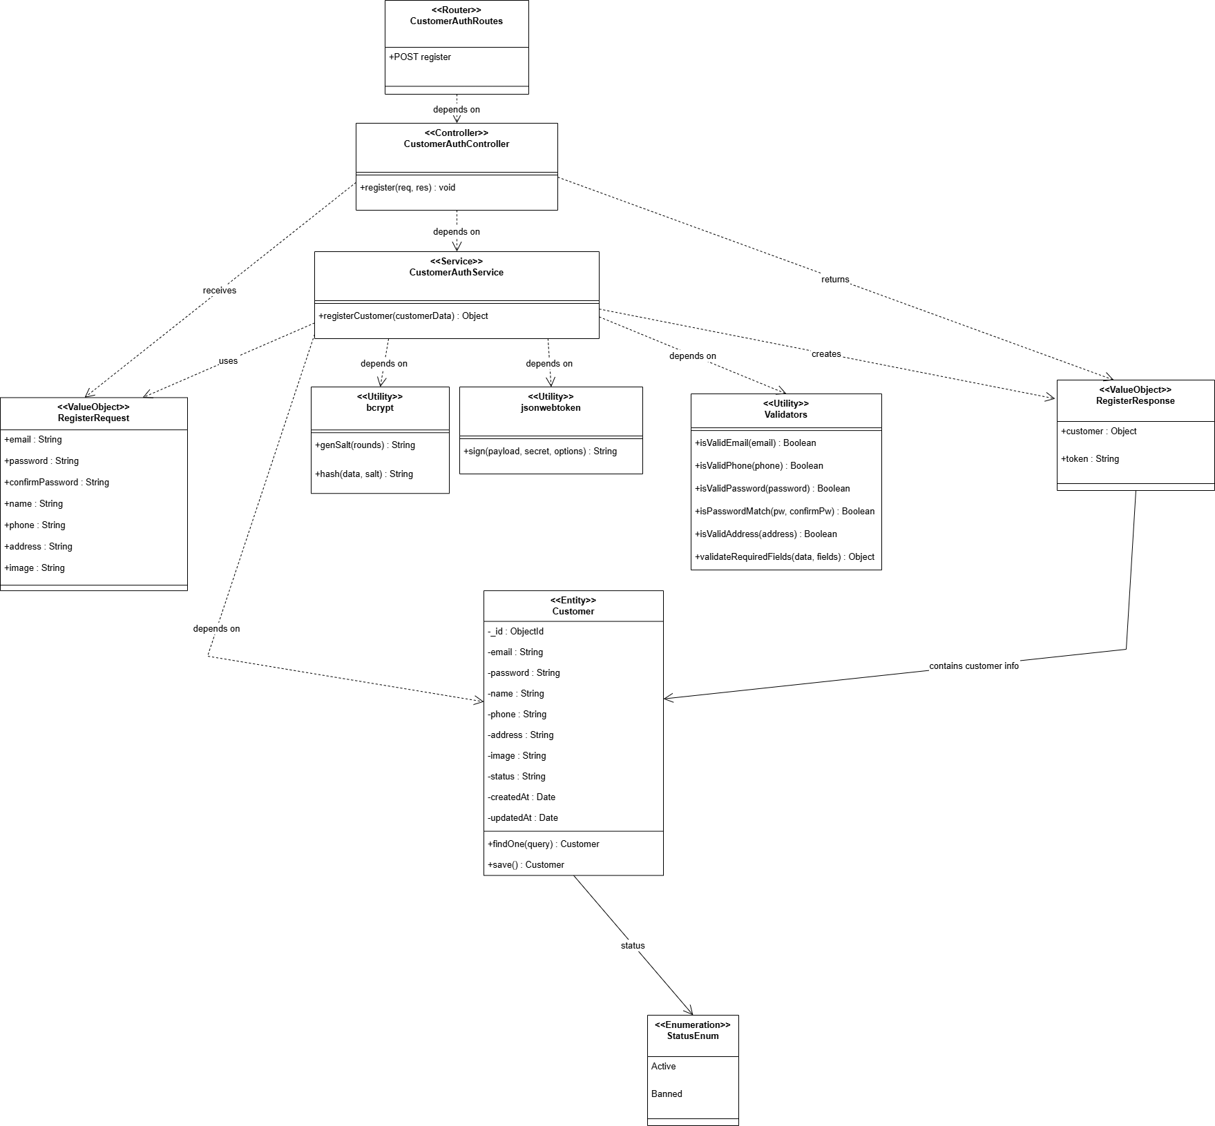
Figure II.5: Class diagram - Register

2.2 Class Specifications
Table II.3: Class specification - Register
No | Method | Description
1 | registerCustomer(req, res) | - Input: HTTP Request  - Output: HTTP Response  Processing:  - Extract data from req.body  - Validate that the request body contains all required fields  - Call RegisterService.registerCustomer(data)  - Return 201 Created with customer data (excluding password)  - Catch error
- Class RegisterService

No | Method | Description
1 | registerCustomer(registerData) | - Input: Object {name, email, password, phone?, address?}  - Output: Promise<Customer> (without password field)  Processing:  - Validate all input data via ValidationService.validateRegisterData().  - Throw ValidationException if data is invalid.  - Check if email exists: checkEmailExists(email).  - Hash password via PasswordService.hashPassword(password).  - Prepare customer object:  + name, email, password (hashed)  + phone, address (if any)  + image = null (default)  + createdAt, updatedAt will be auto-set.  - Call CustomerRepository.createCustomer(customerData).  - Remove password field from the returned object.  - Return customer object.  - Catch error
2 | checkEmailExist(email) | - Input: String email  - Output: Promise<boolean>  Processing:  - Call CustomerRepository.findByEmail(email).  - If a customer found → Throw ConflictException("Email already registered").  - If not found → Return false (email available).

- Class ValidationService

No | Method | Description
1 | validateEmail(email) | Input: String email  Output: ValidationResult {isValid: boolean, message?: string}  Processing:  - Check if the email is null/undefined/empty.  - Validate email format  - Check email length <= 255 characters.  - Return {isValid: true} if valid.  - Return {isValid: false, message: "Invalid Email"} if failed.
2 | validatePassword(password) | Input: String password  Output: ValidationResult {isValid: boolean, errors?: string[]}  Processing:  - Check not empty.  - Check min length >= 8 characters.  - Check at least 1 uppercase (A-Z).  - Check at least 1 lowercase (a-z).  - Check at least 1 number (0-9).  - Check at least 1 special char (!@#$%^&*).  - Collect all errors into an array.  - Return result.
3 | validatePhone(phone | Input: String phone  Output: ValidationResult {isValid: boolean, message?: string}  Processing:  - If the phone is null/undefined/empty → Return {isValid: true} (optional field).  - Validate Vietnamese phone format  - Return result.

- Class PasswordService

No | Method | Description
1 | hashPassword(password) | Input: String password (plaintext)  Output: Promise<string> hashed password  Processing:  - Import bcrypt library.  - Generate salt with cost factor 12: bcrypt.genSalt(12).  - Hash password: bcrypt.hash(password, salt).  - Return hashed string (e.g., $2b$12...).
2 | comparePassword(password, hash) | Input: String password (plaintext), String hash  Output: Promise<boolean>  Processing:  - Use bcrypt.compare(password, hash).  - Return true if match, false otherwise.

2.3 Sequence Diagram(s)
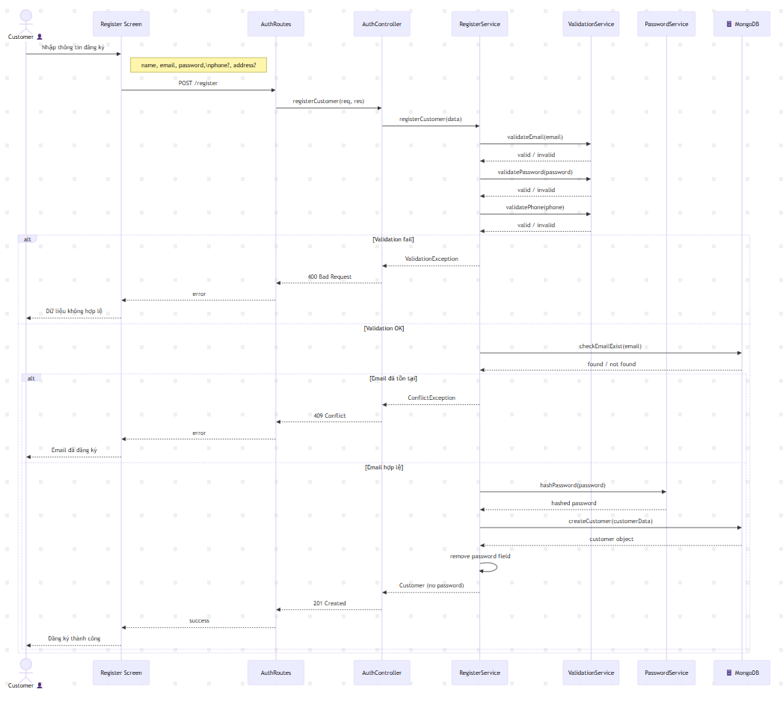
Figure II.6: Class diagram - Manager Login

3. Feedback

3.1 Class Diagram
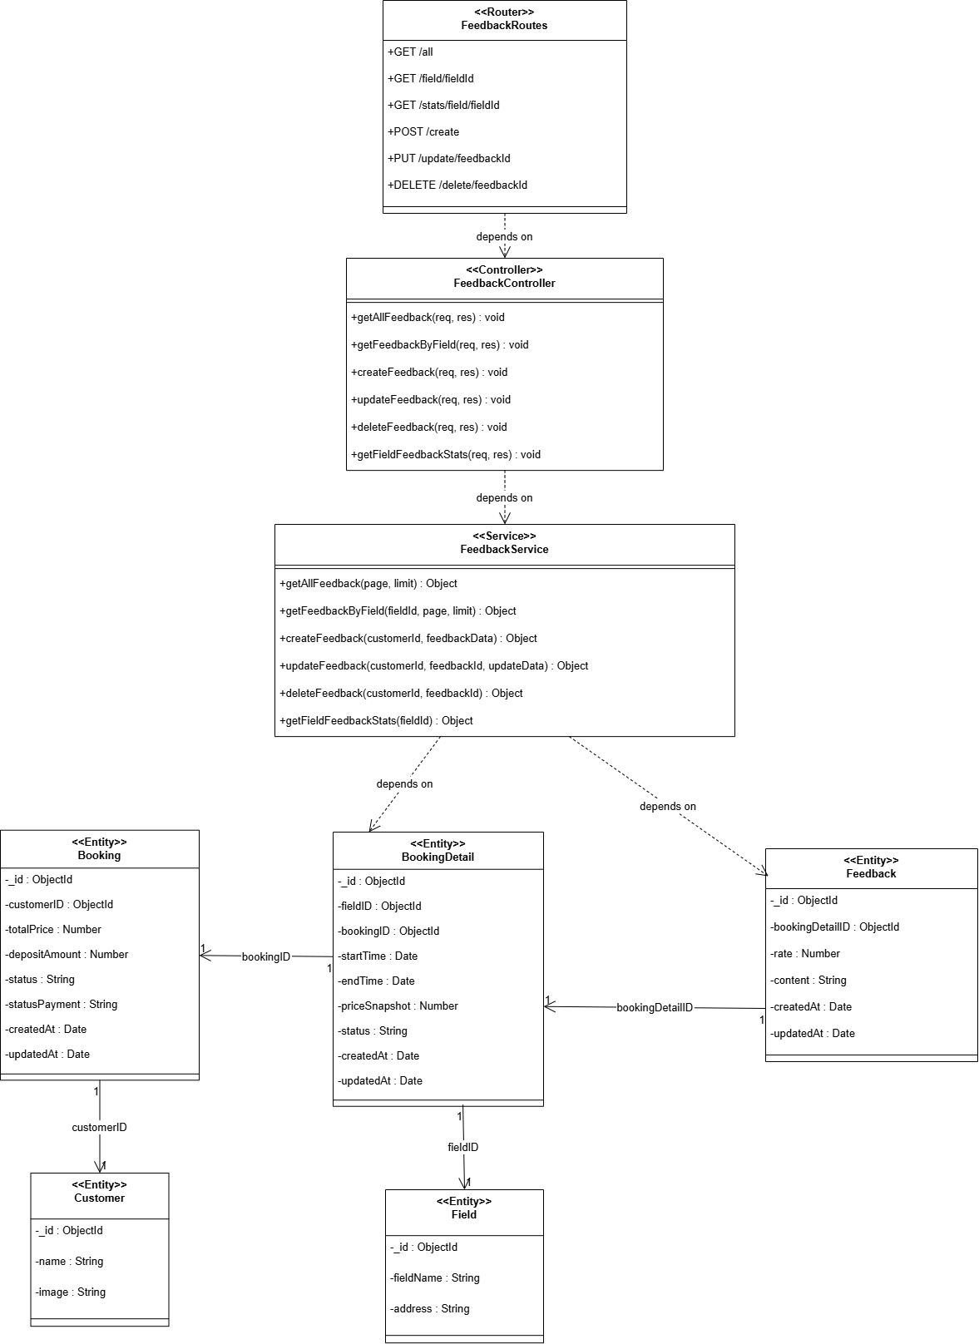
Figure II.7: Class diagram - Feedback

3.2 Class Specifications
Table II.4: Class specification - Feedback
- Class FeedbackController
No | Method | Description
1 | createFeedback  (req, res) | - Input: HTTP Request  - Output: HTTP Response  Processing:  - Extract data from req.body  - Validate that the request body contains all required fields  - Call FeedbackService.createFeedback(data)  - Return 201 Created with feedback data  - Catch error
2 | getFeedbacksByField  (req, res) | - Input: HTTP Request (fieldId in params)  - Output: HTTP Response  Processing:  - Extract fieldId from req.params  - Call FeedbackService.getFeedbacksByFieldId(fieldId)  - Return 200 OK with array of feedbacks  - Catch error

- Class FeedbackService

No | Method | Description
1 | createFeedback  (feedbackData) | - Input: Object {userId, fieldId, bookingId, rating, comment}  - Output: Promise<Feedback>  Processing:  - Validate all input data via ValidationService.validateFeedbackData()  - Throw ValidationException if data is invalid  - Check if user has booked: checkUserHasBooked(userId, fieldId)  - If user hasn't completed booking → Throw ConflictException("User must complete booking first")  - Sanitize comment input via ValidationService.sanitizeInput(comment)  - Create new Feedback instance:  - + userId, fieldId, bookingId, rating, comment  - + images = [] (default)  - + status = "active" (default)  - + createdAt, updatedAt will be auto-set  - Call feedback.save() to save to database  - Return saved feedback object  - Catch error
2 | checkUserHasBooked  (userId, fieldId) | - Input: String userId, String fieldId  - Output: Promise<boolean>  Processing:  - Call Booking.find({userId, fieldId, status: 'completed'})  - If booking found → Return true (user eligible to give feedback)  - If not found → Return false
3 | getFeedbacksByFieldId  (fieldId) | - Input: String fieldId  - Output: Promise<Feedback[]>  Processing:  - Call Feedback.find({fieldId})  - Populate user information (name, avatar)  - Sort by createdAt descending (newest first)  - Return array of feedback objects  - If no feedbacks found → Return empty array []

- Class ValidationService

No | Method | Description
1 | validateFeedbackData  (data) | - Input: Object {userId, fieldId, rating, comment}  - Output: ValidationResult  Processing:  - Check if userId exists and is valid ObjectId  - Check if fieldId exists and is valid ObjectId  - Validate rating via validateRating(rating)  - Validate comment via validateComment(comment)  - Return ValidationResult {isValid: true/false, errors: []}
2 | validateRating  (rating) | - Input: Number rating  - Output: ValidationResult  Processing:  - Check if rating is a number  - Check if rating is between 1-5  - If invalid → Return {isValid: false, error: "Rating must be between 1-5"}  - If valid → Return {isValid: true}
3 | validateComment  (comment) | - Input: String comment  - Output: ValidationResult  Processing:  - Check if comment is required (not empty)  - Check minimum length: 10 characters  - Check maximum length: 500 characters  - If invalid → Return {isValid: false, error: "message"}  - If valid → Return {isValid: true}
4 | sanitizeInput  (input) | - Input: String input  - Output: String (sanitized)  Processing:  - Remove HTML tags to prevent XSS attacks  - Trim whitespace from beginning and end  - Escape special characters (<, >, &, ", ')  - Return cleaned string

- Class ValidationService

No | Method | Description
1 | save() | - Input: None (instance method)  - Output: Promise<Feedback>  Processing:  - Save current feedback instance to MongoDB  - Auto-generate _id, createdAt, updatedAt  - Return saved feedback document  - Catch database error
2 | find() | - Input: Object query (e.g., {fieldId: "123"})  - Output: Promise<Feedback[]>  Processing:  - Query MongoDB collection with provided filters  - Return array of matching feedback documents  - Return empty array [] if no matches found
3 | findByIdAndUpdate() | - Input: String id, Object updateData  - Output: Promise<Feedback>  Processing:  - Find feedback by _id  - Update fields with new data  - Auto-update updatedAt timestamp  - Return updated feedback document  - Return null if id not found

3.3 Sequence Diagram(s)
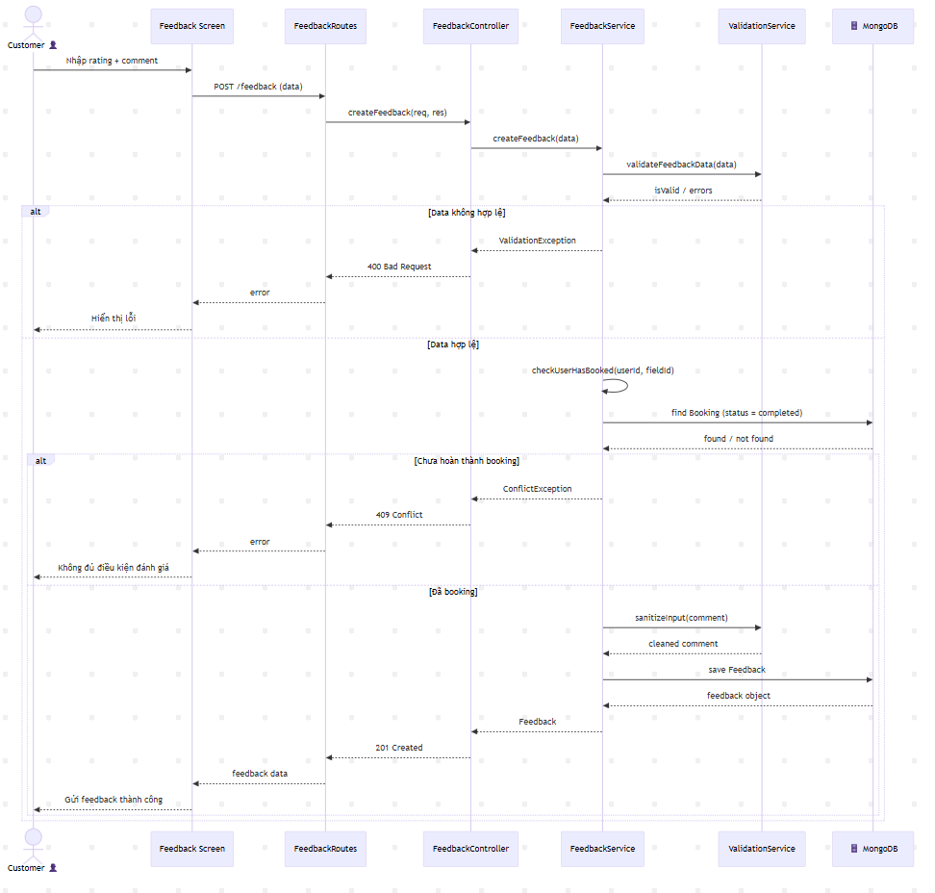
Figure II.8: Sequence diagram - Feedback
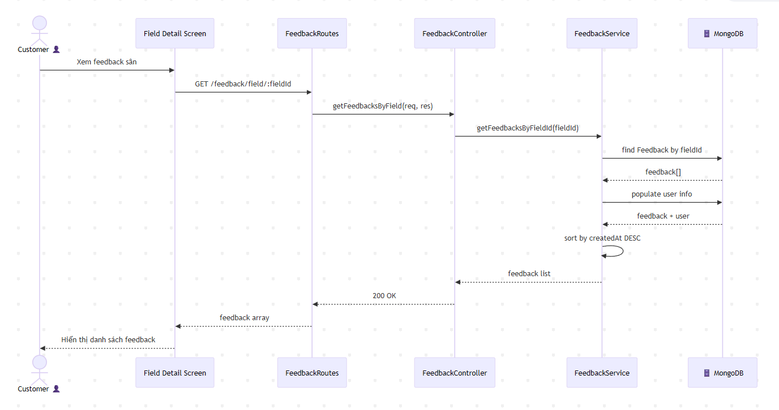
Figure II.8: Sequence diagram - Get Feedback by Field

4. Booking field

4.1 Class Diagram
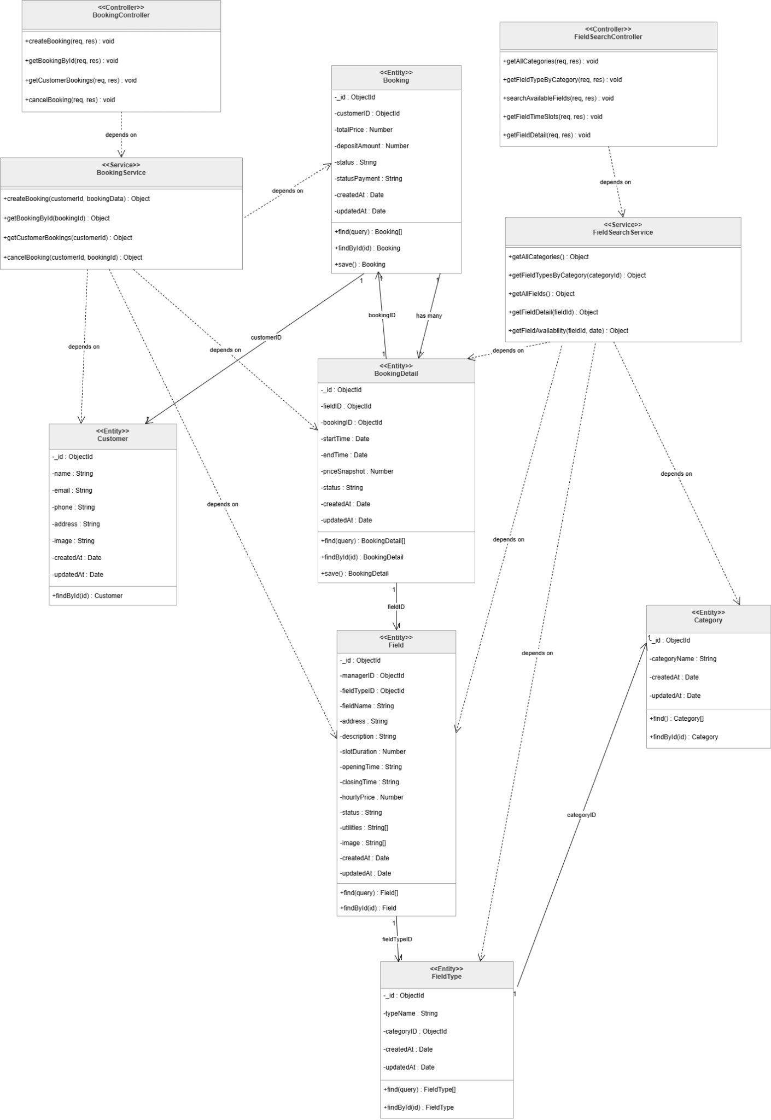
Figure II.9: Class diagram - Booking

4.2 Class Specifications
Table II.5: Class specification - Booking
- Class FieldSearchController
No | Method | Description
01 | getAllCategories(req, res) | Input: req, res objects  Output: JSON response (200 OK / 500 Error)  Processing:  1. Call FieldSearchService.getAllCategories()  2. If success: return JSON {success: true, data: categories}  3. If error: return 500 and log error.
02 | getFieldTypesByCategory(req, res) | Input: req.params.categoryId  Output: JSON response (200 / 400 / 404 / 500)  Processing:  1. Validate categoryId. Return 400 if invalid.  2. Call FieldSearchService.getFieldTypesByCategory().  3. Return 404 if service throws "Not Found".  4. Return 200 with data if success.
03 | searchAvailableFields(req, res) | Input: req.query (fieldTypeId, date, startTime, endTime, location)  Output: JSON response (200 / 400 / 500)  Processing:  1. Validate required query params.  2. Build criteria object.  3. Call FieldSearchService.searchAvailableFields(criteria).  4. Return result with total count.
04 | getFieldTimeSlots(req, res) | Input: req.params.fieldId, req.query.date  Output: JSON response (200 / 400 / 404 / 500)  Processing:  1. Validate parameters.  2. Call FieldSearchService.getAvailableTimeSlots().  3. Return field info + time slots.  4. Handle 404/500 errors.
05 | getFieldDetail(req, res) | Input: req.params.fieldId  Output: JSON response (200 / 404 / 500)  Processing:  1. Call FieldSearchService.getFieldDetail().  2. Return full field details.  3. Handle errors.
- Class BookingController

No | Method | Description
01 | createBooking(req, res) | Input: req.user.id, req.body (booking_date, bookingDetails)  Output: JSON response (201 Created / 400 / 409 / 500)  Processing:  1. Validate request structure.  2. Call BookingService.createBooking().  3. Handle specific errors:  • "đã được đặt" → 409 Conflict  • "không hợp lệ" → 400 Bad Request  • Other → 500 Error
02 | getBookingById(req, res) | Input: req.params.id  Output: JSON response (200 / 404 / 500)  Processing:  1. Call BookingService.getBookingById().  2. Return booking details.  3. Return 404 if not found.
03 | getCustomerBookings(req, res) | Input: req.user.id  Output: JSON response (200 / 500)  Processing:  1. Call BookingService.getCustomerBookings().  2. Return list of bookings sorted by date.
04 | cancelBooking(req, res) | Input: req.params.id, req.user.id  Output: JSON response (200 / 400 / 403 / 500)  Processing:  1. Call BookingService.cancelBooking().  2. Handle errors:  • Not owner → 403 Forbidden  • Policy violation (<24h) → 400 Bad Request

- Class FieldSearchService
No | Method | Description
01 | getAllCategories() | Output: Promise<Category[]>  Processing:  1. Query Category.find().  2. Sort by name.  3. Return array.
02 | getFieldTypesByCategory(id) | Output: Promise<FieldType[]>  Processing:  1. Check Category exists.  2. Query FieldType.find({ category_id }).  3. Return array.
03 | searchAvailableFields(criteria) | Output: Promise<Field[]>  Processing:  1. Get list of FieldTypeAddress IDs.  2. Find Active Fields matching type.  3. Filter by Location (if provided).  4. Check Availability: Filter out fields with overlapping BookingDetails.  5. Calculate Slot Price.  6. Populate Address info.
04 | getAvailableTimeSlots(id, date) | Output: Promise<Object> (slots)  Processing:  1. Validate Field status.  2. Generate all possible slots based on opening_time and slot_duration.  3. Query BookingDetail for that date.  4. Mark slots as "Booked" if they overlap with existing bookings.  5. Return list.
05 | getFieldDetail(id) | Output: Promise<Object>  Processing:  1. Query Field.findById().  2. Populate FieldType, Address, Images, Utilities.  3. Return full object.

- Class BookingService

No | Method | Description
01 | createBooking(custId, data) | Input: CustomerID, BookingData  Output: Promise<Booking>  Processing:  1. Validate data via ValidationService.  2. Verify Customer exists.  3. Loop details:  • Check the Time Slot is valid.  • Check Field Status (Active).  • CRITICAL: Check Conflict (Is booked?).  • Calculate Price Snapshot.  4. Calculate Total Price & Deposit.  5. DB Transaction: Create Booking & Insert BookingDetails.  6. Return populated Booking.
02 | getBookingById(id) | Processing:  1. Find Booking.  2. Find related BookingDetails.  3. Populate Field info for each detail.  4. Return combined object.  Output: Promise<FieldType[]>  Processing:  1. Check Category exists.  2. Query FieldType.find({ category_id }).  3. Return array.
03 | getCustomerBookings(custId) | Processing:  1. Find Bookings by CustomerID (Sort DESC).  2. Populate details for each booking.
04 | cancelBooking(bookId, custId) | Output: Promise<Boolean>  Processing:  1. Find Booking.  2. Verify Owner: Check customer_id matches.  3. Check Policy: Ensure startTime - now > 24 hours.  4. Update BookingDetails status to 'Cancelled'.  5. Update Booking payment_status to 'Cancelled'.
- Other Service

Service | Method | Description
ValidationService | validateBookingData | Checks required structure (date, details array).
 | validateTimeSlot | Checks: Start < End, Not in Past, Min Duration (30m).
PriceCalculationService | calculateSlotPrice | Formula: hourlyPrice * ((end - start) / 3600000).
 | calculateTotalPrice | Sum of all priceSnapshots.
 | calculateDepositAmount | Sum of all priceSnapshots.

4.3 Sequence diagram
a. Search Available Fields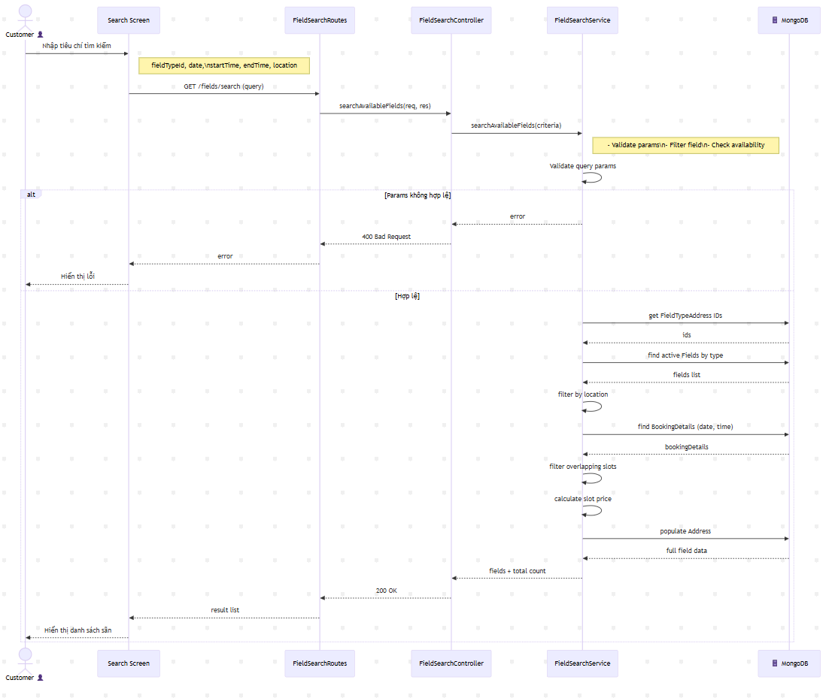
Figure II.10: Sequence diagram - FieldSearch
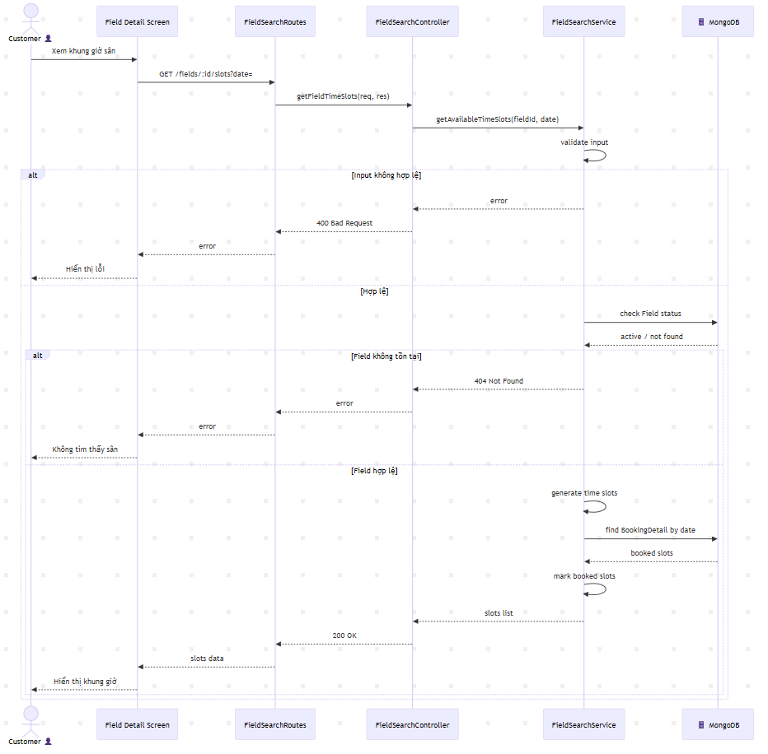
Figure II.10: Sequence diagram - FieldTimeSlotSearch

- Booking Field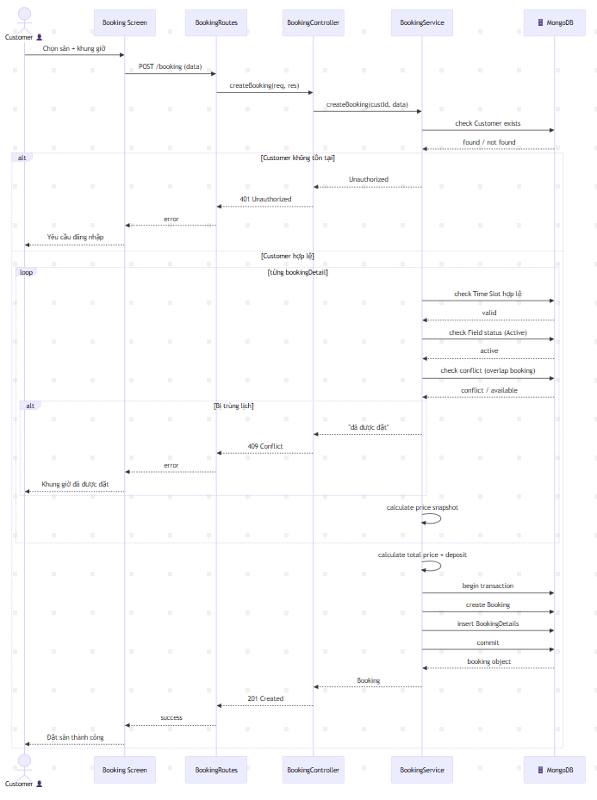
Figure II.11: Sequence diagram - Booking
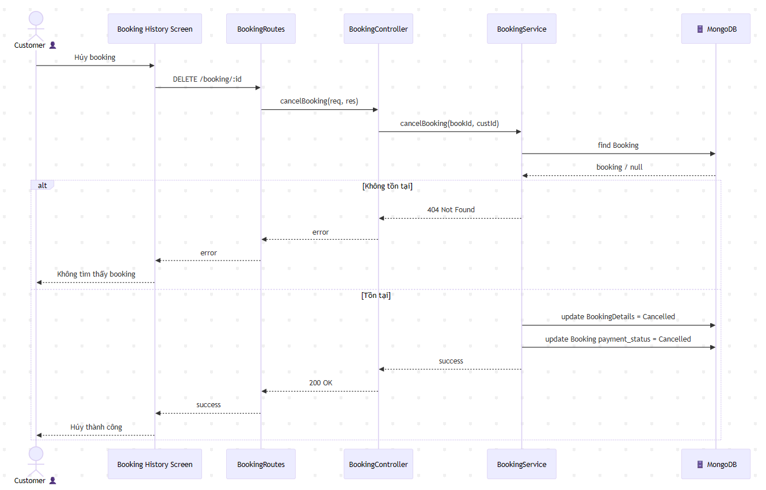
Figure II.11: Sequence diagram - Cancel Booking

